**Lab MST**

**Student Name**: Sahil Kaundal **UID:** 21BCS8197

**Branch**: CSE(LEET) **Section/Group:** 807/B

**Semester**: 4th **Date of Performance**: 30/03/2022

**Subject Name**: CN Lab **Subject Code:**20CSP-257

**Question:**

10 people are sitting in a room. If they want to communicate with each other, what will be the best transmission media to be used and why?

**Answer:**

The best way to communicate with each other is to use cables for communication.

Through the wire they all can connect each other in easy way and share data or communicate with each other.

10 people are sitting in a room. If they want to communicate with each other, Coaxial cable is the best transmission media to be used as it supports multi channel.

So, if we need to add more devices then we can extend it.

Also there are some features of coaxial cable which make it best multi channel

**Transmission media:**

Coaxial cables support high bandwidth.

Easy to install coaxial cables.

Coaxial cables have better cut-through resistance so they are more reliable and durable.

Less affected by noise or cross-talk or electromagnetic inference.

There are types of cables for connecting the computers:

* **Coaxial cables:** Coaxial cables have a single copper conductor at the center, while a plastic layer provides insulation between the center conductor and braided metal shield. The metal shield blocks outside interference from fluorescent lights, motors, and other computers.

A coaxial cable is an electrical cable with a copper conductor and an insulator shielding around it and a braided metal mesh that prevents signal interference and cross talk. Coaxial cable is also known as **coax.**

The core copper conductor is used for the transmission of signals and the insulator is used to provide insulation to the copper conductor and the insulator is surrounded by a braided metal conductor which helps to prevent the interference of electrical signals and prevent cross talk. This entire setup is again covered with a protective plastic layer to provide extra safety to the cable.

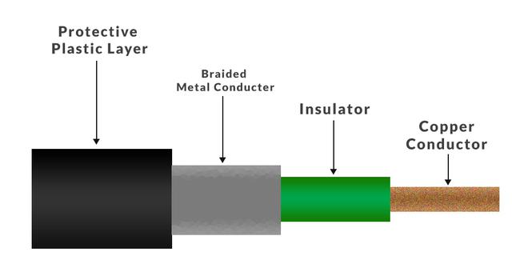

* **Fiber optic cables:** Fiber optic cables possess a center glass core surrounded by multiple layers of protective materials. They avoid electrical obstruction by transmitting light instead of electronic signals, making them perfect for environments with large amounts of electrical interference.
* An **Optical Fiber** is a cylindrical fiber of glass which is hair thin size or any transparent dielectric medium. The fiber which is used for optical communication is waveguides made of transparent dielectrics.
* 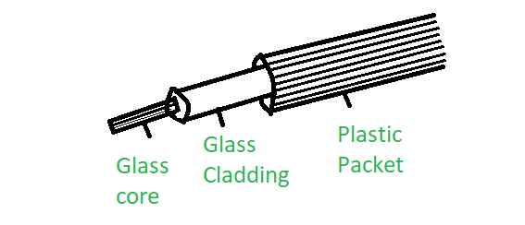

**Shielded Twisted Pair (STP) Cable:** Often referred to colloquially as simply ethernet cables, STP cables employ a special type of copper telephone wiring used for business installations. An external shield functioning as a ground is added to the standard twisted pair of telephone wires.

STP is also the type of twisted pair which stands for Shielded twisted pair. In STP grounding cable is required but in UTP grounding cable is not required. in Shielded Twisted Pair (STP) much more maintenance are needed therefore it is costlier than Unshielded Twisted Pair (UTP).

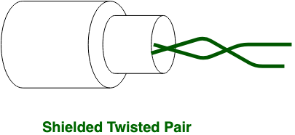

**Result:-**

I have successfully completed this experiment.

**Learning outcomes (What I have learnt):**

1. Learned about different Cables.
2. Coaxial Cable.
3. Fibre Optics Cable.
4. Shielded Twisted Pair Cable (STP).

**Evaluation Grid (To be created as per the SOP and Assessment guidelines by the faculty):**

|  |  |  |  |
| --- | --- | --- | --- |
| Sr. No. | Parameters | Marks Obtained | Maximum Marks |
| 1. |  |  |  |
| 2. |  |  |  |
| 3. |  |  |  |
|  |  |  |  |